Preface

This User Guide explains how to use the system to set up export credit agency facilities and process drawdowns against them. It assumes that you are familiar with the basic principles of trade finance relating to export credit agency facilities, and with web browsers.

# About Export Credit Agency Facility

Trade Innovation supports export credit agency facilities, whereby an export credit agency lodges funds with your bank for the purpose of providing short-term loans to exporters who are customers of your bank.

Each such lodgement of funds is recorded in the system using a single product - the Export Credit Agency Facility product. Your bank can distinguish between different types of export credit agency facilities by setting up product types for that purpose. The rules facility can then be used to govern how a facility should be handled, depending on its product type.

An export credit agency facility is set up for a specific customer following agreement with the export credit agency (also known as the funding party).

Loans against an export credit agency facility are handled using financing transactions, which are linked to the relevant export credit agency facility. The facility can be set up before the financing transaction, or at the same time.

As a financing transaction is linked to a facility, the amount of the facility is reduced by an equivalent amount using an automatically generated Drawdown/Revolve Facility event.

The cost-of-funds interest payments due to export credit agencies are set up using interest types, and the scheduled interest payments are calculated and made to the funding party either automatically according to the schedule or when a repayment is made against a linked financing transaction (this is determined by product type settings).

If regular automatic payments are used, overnight processing identifies when payment to facilities belonging to a particular product type are due, and generates a single payment per facility. Each payment includes interest across all the financing transactions linked to the relevant facility.

An export credit agency facility can be blocked at any time by your bank (and subsequently unblocked) if required. This has no effect on financing transactions linked to the facility, but does prevent any further financing transactions from being linked to it.

This chapter provides an overview of how the system handles export credit agency facilities and introduces the terminology used in this Guide.

## Revolving Export Credit Agency Facilities

Export credit agency facilities can be revolving. For a revolving export credit agency facility, as financing transactions are linked to the facility, the amount of the facility is reduced by an equivalent amount using an automatically generated Drawdown/Revolve Facility event in the standard way. In addition, an automatically generated Drawdown/Revolve Facility event is generated to increase the facility's available amount (up to the originally agreed total amount) whenever linked financing transactions are paid or expired. For example, if an export credit agency facility is agreed to a total value of 1,000,000 USD and it is linked to two financing transactions of 350,000 USD each, the amount available is reduced to 300,000 USD. If one of the linked financing transactions is subsequently paid off, the amount available against the export credit agency facility would stay at 300,000 USD if the facility is not revolving, but would rise to 650,000 USD if it is revolving.

## Financing Transactions Used with Export Credit Agency Facilities

The following financing products can be linked to an export credit agency facility:

* Finance Standalone
* Finance Export LC (for export letters of credit, guarantees and standby letters of credit)
* Finance Outward Collection

For more information on the different financing products see the Financing User Guide – Trade Innovation.

## Using Trade Innovation to Process Export Credit Agency Facilities

The table below list the events covered in this Guide, explaining what each event allows you to do. The table lists the names given to events when the system is delivered. Your bank can change these names once the system is installed. Consequently, the names in your version of the system may be different from the ones listed here.

There are two names for each event:

* The full name, which is displayed when you choose a new event
* The short name, which is displayed in the Work in Progress pane of the Master Summary window

This Guide uses the full name of each event, as delivered with the system.

In addition to the events listed in the table, you can also use the functionality described in the Common Facilities User Guide – Trade Innovation when processing transactions in the system.

|  |  |  |
| --- | --- | --- |
| Full Name | Short Name | What it Does |
| Adjust EC Agency Facility | Adjust | Allows you to make changes to any of the information held for an export credit agency facility (see page 19). |
| Amend EC Agency Facility | Amend | Allows you to make amendments to the basic details of an export credit agency facility (see page 18). |
| Cancel EC Agency Facility | Cancel | Allows you to cancel an export credit agency facility (see page 22). |
| Create EC Agency Facility | Create | Allows you to create a new export credit agency facility (see page 7). |
| Drawdown/Revolve Facility | Drawdn/Rev | Decreases the amount available against an export credit agency facility when a financing transaction is linked to it (see page 23).  For revolving export credit agency facilities, this event reinstates the corresponding amount when a repayment is made against a financing transaction (see page 23). |

## Using Deal Templates to Create an Export Credit Agency Facility

Trade Innovation permits you to create deals (transactions) from templates and/or, if you have the capability ManageDealTemplates assigned, to add, update and delete deal templates.

You can create a new export credit agency facility from a template at one of three points:

* From within the TI Dashboard. In the New Master pane, the Create from Template button allows you to select the template to use. You must specify the Team, the Branch and the Product
* From within the Master Browser window. In the New Master pane, the Create from Template button allows you to select the template to use. You must specify the Team, the Branch and the Product
* From within a transaction, during the Input step of an event that is creating a new master record. The Create from Template link allows you to select the template to use

See the *Common Facilities User Guide – Trade Innovation* for further details*.*

# Before you Begin

There are some steps that your bank must take before it can begin using the system to process export credit agency facilities. This chapter identifies each of these steps.

In addition to the system tailoring discussed in this chapter, your bank will also need to set up postings, charges, customer documents, clauses and tracers for export credit agency facilities in the usual way. See the System Tailoring User Guide – Trade Innovation for instructions.

## Product Types

Product types are used to categorise transactions and, for financing transaction, to provide default processing options. Your bank can define a separate product type for each type of export credit agency facility it handles. When a new export credit agency facility is created, the user can then select the relevant product type to flag the facility as, for example, involving pre-shipment export credit refinancing or a clean banker's acceptance.

Product types can be used as filters when running reports and when setting up working profiles. They can also be used as criteria when setting rules governing how transactions are handled, allowing your bank to process different types of export credit agency facilities in different ways.

1. Finastra recommend that you set the product type to be mandatory for the Export Credit Agency facility product.

See the System Tailoring User Guide – Trade Innovation for instructions on setting up product types and product options.

## Interest Types

Your bank will need to set up the interest types and schedules to be used by financing transactions related to export credit agency facilities. Interest types and schedules allow your bank to define how interest for your bank and interest to cover cost of funding for the export credit agency is to be calculated.

Your bank is able to set up separate schedules for the main term of the deal and for the 'past due' period.

See the System Tailoring User Guide – Trade Innovation for instructions on setting up interest types and schedules.

## System Options

The following system options are relevant to the processing of export credit agency facilities:

Under the category 'General':

|  |  |
| --- | --- |
| CalendarUnexpectedHolidays | If the flag is checked (Yes), then the system will allow unexpected holidays to be recorded against calendars in the static data maintenance application. |

Under the category 'Financing':

|  |  |
| --- | --- |
| CustCOFAccrualAccType | If this is present, cost-of-funds accruals will be posted to customer accounts, using the account type specified in the Value field. |
| EnableSeparateCostOfFunds | If the flag is checked (Yes), then functionality will be enabled, allowing relevant financing transactions to be linked to an export credit agency as they are created. |

For instructions on setting these system options see the System Tailoring User Guide – Trade Innovation.

## Overnight Batch Processing

Overnight batch processing includes the following action to handle the calculation and payment of month-end interest to the funding party:

* Financing Auto Cost of Funds

This action generates monthly interest payments to the funding party for all financing transactions associated with an export credit agency facility.

See the Business Operations User Guide – Trade Innovation for more details.

## Security

The financing transaction capability UpdateFundingPartyRate is used to control whether users can amend the interest rate used to calculate the cost of funding for funding parties during Create, Amend, Adjust events and repayment events for financing transactions. The setting on the product type will override the capability setting for individual users.

For instructions on setting this capability see the Security User Guide – Trade Innovation.

## Additional System Tailoring

The product type attached to an export credit agency facility in the system can be used as a criterion in setting rules, allowing your bank to differentiate between how different types of facility are handled. The product type can also be used as a criterion when defining error messages and warning messages, allowing your bank to highlight issues relating, for example, to breaches of limits on amounts and maximum finance periods. Again, the product type can be used to differentiate between how such issues are handled, allowing your bank to configure the system to produce a warning message for one type of facility (allowing the input clerk to complete the event without having to correct the data already entered) whilst producing an error message (which forces the input clerk to correct the data) for another.

The system tailoring application allows you to define up to five different fields (and associated values) for each product. During transaction processing the input clerk selects the appropriate value in each field. These bank-definable fields can be used to enter additional data against an export credit agency facility or a related financing transaction.

If your bank uses the customisation facilities, your bank can further extend the information recorded against export credit agency facilities.

See the System Tailoring User Guide – Trade Innovation for instructions on setting up rules, error and warning messages and bank-definable fields; and the Customisation User Guide – Trade Innovation forinformation on customising your installation.

## Setting Up a Debit Interest Reconciliation Report

The system allows your bank to design its own reports, as described in the Report Tailoring User Guide – Trade Innovation.

The reporting view Funding Party Debits is provided to allow your bank to set up a report that facilitates the reconciliation of scheduled interest debit accounting entries. The report can be set up to include basic information from the master record, including the branch, customer, finance debit party identifier and master/financing transaction reference numbers and also the following detailed information:

* The cost-of-funds interest start and end dates
* The amount of the loan outstanding (and currency)
* The number of days interest
* The cost-of-funds rate
* The cost-of-funds amount

# Creating an Export Credit Agency Facility

This chapter explains how to use the system to create an export credit agency facility, either directly or from within a related financing transaction.

## Creating an Export Credit Agency Facility in Advance

To create an export credit agency facility in advance, in the Masters window, select the Team and Behalf of branch and use the drop-down list in the New Masters pane to select 'Export Credit Agency Facility', then press New. The system creates a Create event at either a Log step or an Input step, depending on how the Workflow orchestration controlling the event is configured. See the *Workflow Tailoring User Guide* – Trade Innovation for details.

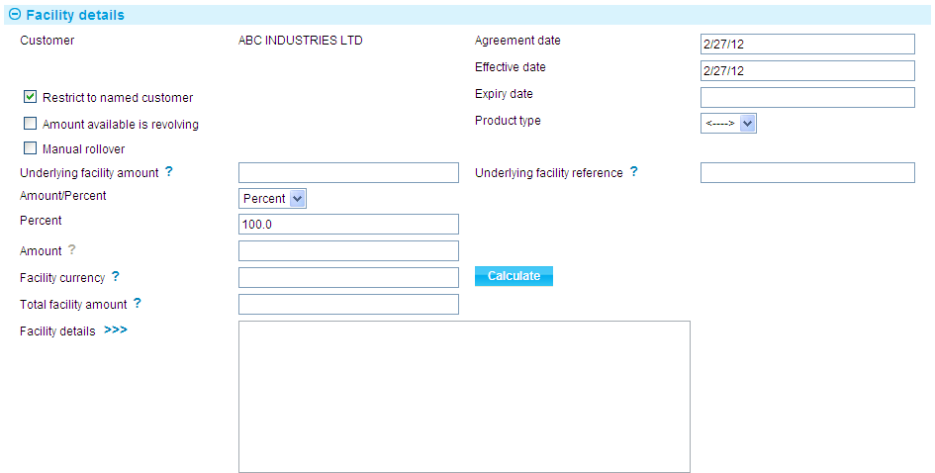 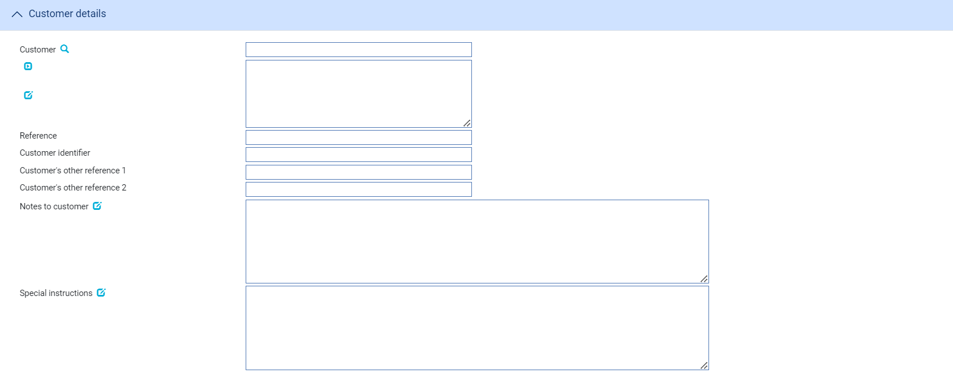

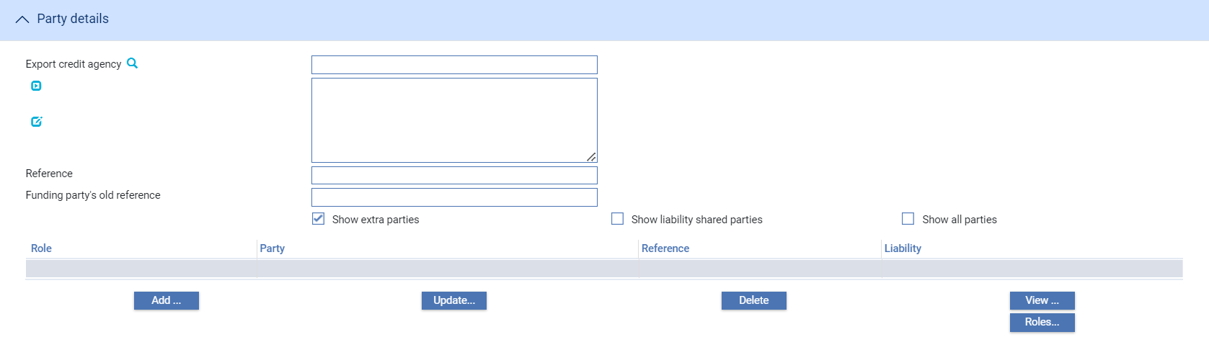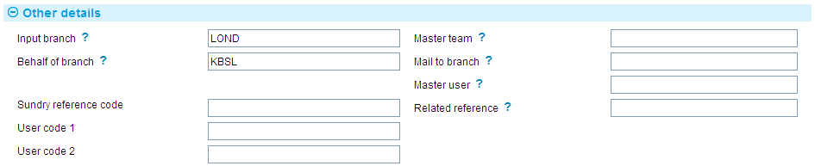

The Create event enables you to enter full details of a new export credit agency facility. The window opened for this purpose uses the following panes:

* The Facility Deal Details pane (see page 8)
* The Customer Details pane (see page 10)
* The Charge Details pane (see page 11)
* The Party Details pane (see page 12)
* The Other Details pane (see page 12)

### The Facility Details Pane



The following table explains what to enter into the fields in the Facility Details pane:

|  | Field | What to Enter |
| --- | --- | --- |
|  | Customer | Once you select a customer (using the next pane) the customer's name is displayed here. |
|  | Agreement Date | The date that the facility was created. The system uses today's processing date as the default. |
|  | Effective Date | The date from which the facility can be used. This must be before the Expiry Date, and may be a past date. The system uses today's processing date as the default. |
|  | Expiry Date | The date that the facility expires. After this date, this deal cannot be linked to new financing transactions. This must be after the Effective Date. |
|  | Restrict to Named Customer | Check this field if the deal is restricted for use with the named customer only. By default, this is checked and the deal is restricted.  You might want to leave this field blank if the participation deal is intended for use with the transactions of several related customers, such as a group of companies. |
|  | Amount Available is Revolving | Check this field if the facility is revolving. For a revolving facility, the commitment amount available is increased when related financing transactions are paid or expired. This is achieved by the relevant event in the financing transaction creating a subsidiary Drawdown/Revolve Facility event against the related export credit agency facility that increases its available amount.  By default, this field is not checked and the facility is not revolving. |
|  | Product Type | Select the appropriate product type from the drop-down list in this field. Depending on how your system has been configured, this field may be mandatory. |
|  | Manual Rollover | If there has already been a rollover against the related Master Certificate of Performance check this flag. |
|  | Underlying Facility Amount | The available amount of underlying instrument, for example an Export Letter of Credit.  This amount is either:   * automatically defaulted when you browse on and select the related transaction via the “Underlying facility reference” field * manually entered if an underlying facility reference is not entered or selected |
|  | Underlying Facility Reference | The reference of the underlying instrument.  You may enter the reference (if known) or browse on and select the underlying instrument, for example an Export Letter of Credit. However, any product/master may be selected.  This field is initially blank. If you select the option to browse for an existing transaction using the ‘?’ button, a Master Browser is made available. This defaults to the Export Letter of Credit (ELC) product and automatically returns a list of all ELCs currently with a ‘Live’ status. The available amount is also displayed. You can now filter on and select the required underlying instrument.  The linkage between the ECF and the underlying instrument may not be updated/detached once the Create event has been authorised. |
|  | Amount/ Percent | The default percentage set up for the ECF at Product Type level.  This represents the maximum percentage that may be drawn down under the ECF. The percentage that defaults has the effect of automatically setting the value displayed in the ‘Amount’ field. If a default has not been set up for the Product Type, the system defaults to ‘100%’.  To manually define the amount of the ECF as a percentage, select ‘Percent’ from the drop-down list and enter the percentage into the ‘Percent’ field. To define the ECF as an amount, select ‘Amount’ from the drop-down list and enter the amount into the ‘Amount’ field. |
|  | Percent | The available percentage.  This is defaulted from the Available Percentage defined at Product Type level. It is also possible for you to manually override the defaulted percentage. |
|  | Amount | The ECF amount, based upon the available percentage.  This defaults automatically if the available percentage is defined on the Product Type. However the system ensures that this does not exceed the maximum percentage allowed.  You are allowed to enter the amount manually if required (see ‘Amount/Percent’ above). |
|  | Facility Currency | This defaults to the “Underlying facility currency” but allows you to manually enter an alternative currency code if required.  Where a different currency is entered, pressing the ‘Calculate’ button automatically defaults the appropriate exchange rate and converts the ECF ‘Amount’ into the new currency. This is displayed in the ‘Total facility amount’ field. |
|  | Total Facility Amount | The total facility amount available to be drawn down in either of the following:   * the underlying facility currency, for example the underlying ELC currency, which is the default * the equivalent foreign currency, where an exchange rate is used |
|  | Exchange Rate | This automatically defaults when you press the ‘Calculate’ button.  The system uses the exchange rate defined in Static Data|Currencies, as the default.  You are allowed to enter a different exchange rate manually. |
|  | Facility Details | General information about the facility (for example, any terms or instructions received from the credit agency, or information on the agreement between your bank and the customer). |

### The Customer Details Pane

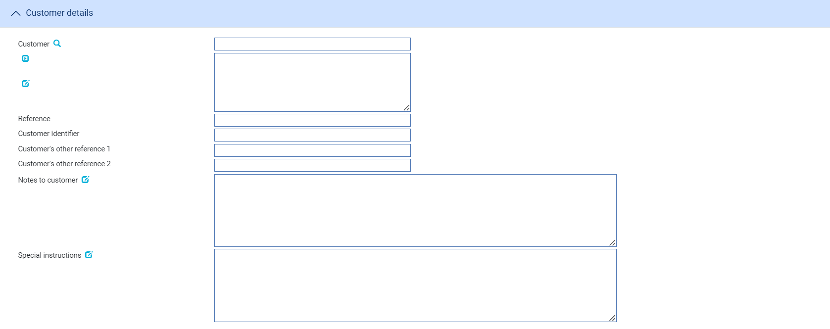

The following table explains what to enter into the fields in the Customer pane:

|  | Field | What to Enter |
| --- | --- | --- |
|  | Customer | The customer for whom the facility is being set up. |
|  | Reference | The customer's reference number for the facility. |
|  | Customer Identifier | The customer's bank register/drawee code to be recorded against drawdowns relating to this transaction. |
|  | Customer's Other Reference 1 | The customer's reference for the Master Certificate of Performance relating to drawdowns against this facility. This reference is automatically recorded against any financing transactions linked to the facility. |
|  | Customer's Other Reference 2 | The customer's reference for the Master Certificate of Performance relating to the facility. |
|  | Notes to Customer | Any information to be included on documents that are sent to the customer. |
|  | Special Instructions | Any special instructions relating to the customer regarding the facility. |

### The Charge Details Pane



The following table explains what to enter into the fields in the Charge Details pane:

|  |  |
| --- | --- |
| Field | What to Enter |
| Preferred Currency | The currency in which the customer's charges will be debited. Typically, you would set this to your local currency. If you leave this field blank, the system uses the customer charge currency defined in the product options. |
| Defer Charges for Customer | Check this field if the charges are to be deferred. By default, this is not checked and the charges are not deferred. |
| First Date | The date when periodic charges are first taken. After this first date the charges are taken according to the frequency on the charge schedule and the Day in Month entered in the next field. For example:   * Today is 12th October * The charge schedule is set up for monthly charging * The charge schedule specifies that charges are taken in arrears * You specify 14th October in this field and 16 for the Day In Month * Therefore, the system will take the first charge on 14th October, and thereafter on 16th November, 16th December, and so on   Alternatively:   * Today is 12th October * The charge schedule is set up for monthly charging * The charge schedule specifies that charges are taken in advance * You specify 14th October in this field and 16 for the Day In Month * Therefore, the system will take the first charge on 12th October, the second charge on 14th October, and thereafter on 16th November, 16th December, and so on   If you leave this blank, the system will use the date calculated by the charge schedule.  Any periodic charges will use these dates unless you override the dates (using the Release Items|Charges link - see the Common Facilities User Guide – Trade Innovation for instructions). |
|  |
| Day in Month | The day in each month when periodic charges are to be debited. |

### The Party Details Pane

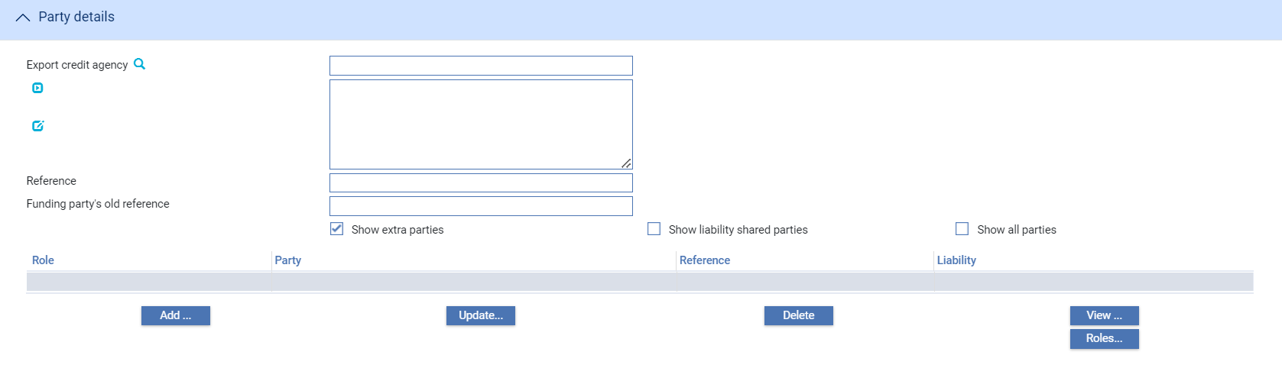

The Export Credit Agency field is used to identify the export credit agency, which is mandatory information. Use the Reference field to enter their reference for the facility. The Funding Party's Old Reference field allows you to enter any previous, superseded, reference for the facility.

The remaining fields and buttons in this pane are used in the usual way, as described in the Common Facilities User Guide – Trade Innovation.

### The Other Details Pane



The following table explains what to enter into the fields in the Other Details pane. This pane may also contain some additional fields defined by your bank:

|  |  |
| --- | --- |
| Field | What to Enter |
| Input Branch | The input branch for the transaction. The input branch is set from either:   * the accounting branch from the user’s team, or * the transaction branch for user if the user has a default transaction branch or is locked to a specific branch, or * a branch associated with the user where the user can enter transactions for several branches for a team |
| Behalf Of Branch | The behalf of branch for the transaction as entered by the user or set from the incoming SWIFT or gateway message. The behalf of branch determines the parameter sets that are to be used to generate charges, documents, postings, etc. during transaction processing. The branch can be changed to any other branch within the same main banking entity that shares the same parameter sets.. |
| Sundry Ref Code /User Code 1/ User Code 2 | You may use these fields to enter values for analysis purposes. Your bank will have devised its own system for using these fields. |
| Responsible Team | The team that has overall responsibility for the master e.g. as the contact to resolve any queries or issues regarding the master and associated events. The system defaults the responsible team when creating the transaction as follows:   * Manual – set from team creating the transaction * Gateway – set from the team specified on the incoming message (if present and valid) otherwise to the team to which the transaction is assigned through workflow allocation based on the behalf of branch * SWIFT – set to the team to which the transaction is assigned through workflow allocation based on the behalf of branch   It can be changed, if required, to either the team associated with the primary customer, default team for the product or the user’s current team. |
| Mail to Branch | The mail to branch can be set to any branch within the main banking entity of the behalf of branch. |
| Responsible User | A user that has responsibility for the master e.g. as the contact to resolve any queries or issues regarding the master and associated events. This can be any user assigned to the responsible team. |
| Related Reference | The reference for any related transaction. |

## The Master Summary Window For Export Credit Agency Facilities

Once you have created an export credit agency facility, the system will display the basic details of that deal using the Master Summary window.

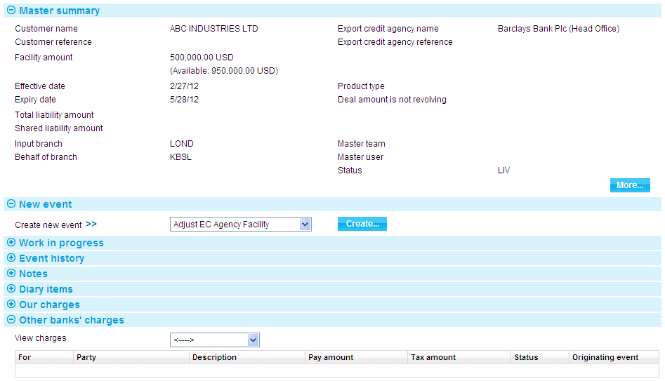

For more information on how the various panes and buttons in this window work see the Common Facilities User Guide – Trade Innovation.

## Linking an Export Credit Agency Facility to a Financing Transaction

A financing transaction is linked to an export credit agency facility at the time that the financing transaction is created. In the Party List pane check the Link to Participation/Facility field.

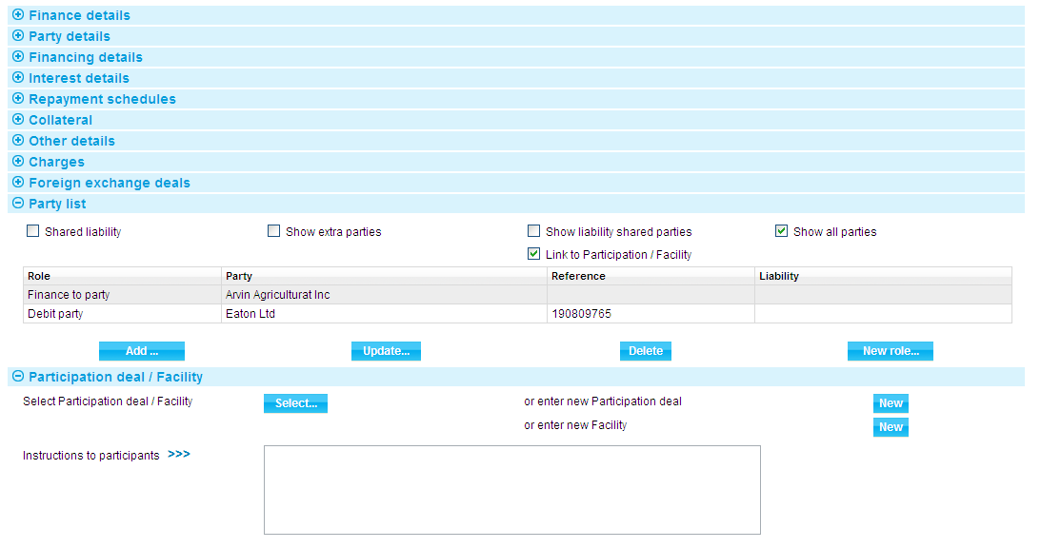

An additional pane is displayed - the Participation Deal/Facility pane. To select the export credit agency facility to which the financing transaction is to be linked press the Select button. In the window that is displayed the system lists all the export credit agency facilities set up for the principal customer (and also any participation deals the principal customer can use).

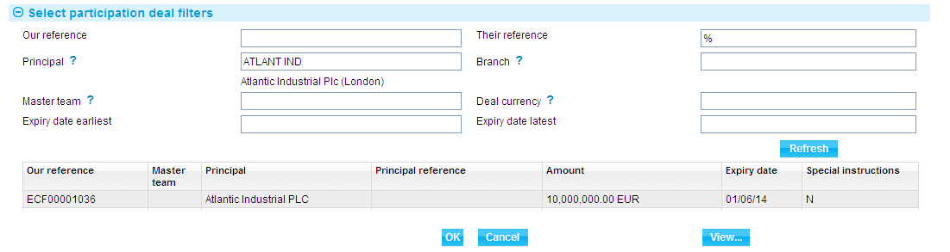

Highlight the required export credit agency facility and press the OK button.

The system closes the window, and displays details of the selected facility in the Participation Deal/Facility pane.

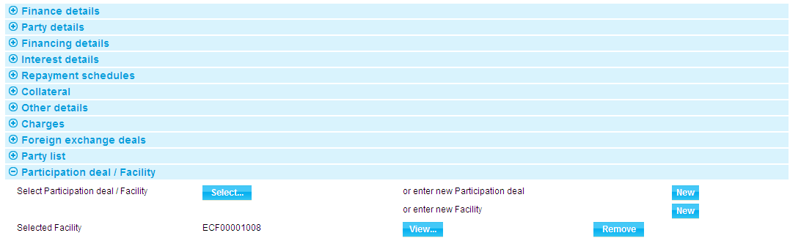

A Remove button is present in the Participation Deal/Facility pane, which you can use to remove the export credit agency facility from the transaction.

1. Once the Create event for the financing transaction has been released, you will not be able to change to a different export credit agency facility or remove the one selected.

See Chapter 6 for more information on the how the system handles the relationship between financing transactions and export credit agency facilities.

## Creating an Export Credit Agency Facility from within a Financing Transaction

When entering details of a financing transaction you can either link it to an existing export credit agency facility or set up a new one to which it is to be linked. This is done from within the Party List pane. Check the Link to Participation/Facility field.



In the Participation Deal/Facility pane, click on the New button next to the label 'or enter new Facility'. The system opens a window that allows you to enter details of a new export credit agency facility. The information entered is the same as for when creating a standalone facility (see page 7), except that the facility must be set up for the principal customer of the financing transaction.

See Chapter 6 for more information on the how the system handles the relationship between financing transactions and export credit agency facilities.

# Making Changes to an Export Credit Agency Facility

This chapter explains how to use the system to make changes to an export credit agency facility.

## Amendments in Trade Innovation

An export credit agency facility can be amended using an Amend event at any time between the release of the Create event and book-off. Amendments may result from a request by any of the parties to the underlying agreement to alter its terms, or from a need to increase the total commitment amount or change the expiry date. Accounting entries and changes to the master record as a result of the amendment are carried out as soon as the Amend event has been released.

The Amend event allows you to make changes to most information relating to an export credit agency facility, including those items that can be expected to change most frequently.

If you change the commitment amount, the system calculates the total amount of all drawdowns against the facility and prevents you from making the change if the new commitment amount is less than that total.

If you change the expiry date, the new expiry date cannot be earlier than the latest expiry date on any linked financing transaction.

If you need to alter any information that cannot be changed using the Amend event, you can use the Adjust event.

The Amend event and the Adjust event both allow you to flag an export credit agency facility as blocked, and to subsequently unblock it, if required. Blocking an export credit facility has no effect on existing transactions linked to the facility, but prevents any new ones from being linked to it.

## Amending an Export Credit Agency Facility

To amend an export credit agency facility, with the appropriate master record open, in the Master Summary window select 'Amend EC Agency Facility' from the Create New Event drop-down list and press Create. The system opens the event at either a Log step or Input step, depending on how the Workflow orchestration controlling the event is configured. See the *Workflow Tailoring User Guide* – Trade Innovationfor details.

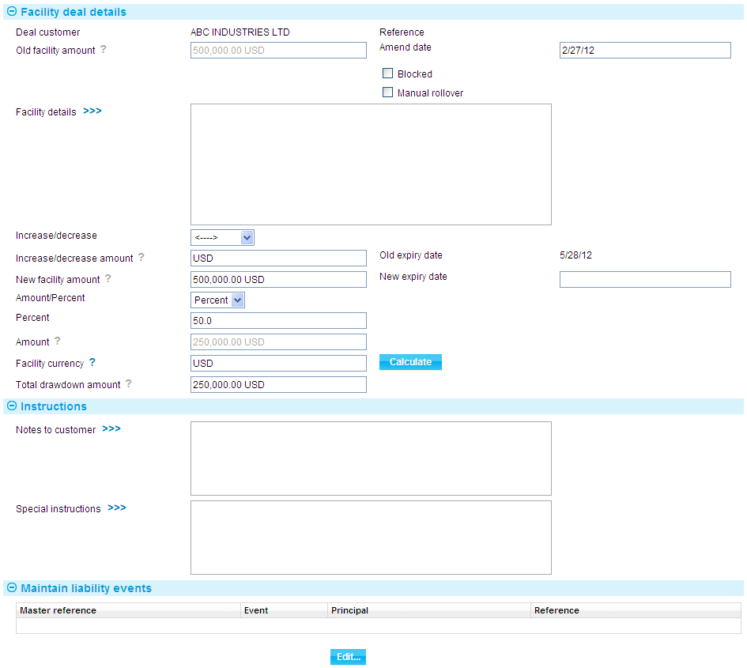

The window displays information on the existing values for the export credit agency facility that can be changed, and provides fields in which you can enter new values.

Use the Amend Date field to enter the date of the amendment.

If the export credit agency facility is to be blocked check the Blocked flag. If there has already been a rollover against the related Master Certificate of Performance check the Manual Rollover flag.

Use the appropriate fields to amend the commitment amount and expiry date of the export credit agency facility.

You can either use the Increase/Decrease field to select whether the change involves an increase or a decrease, then use the Increase/Decrease Amount to enter the value of the increase/decrease.

You can either use the Amount/Percent field to select whether the change involves an amount or a percentage, then enter the value into the Percent or Amount fields. You may enter an alternative currency code and press the ‘Calculate’ button. The system calculates the amended amount and displays it in the New Facility Amount field.

Alternatively just type the new amount into the New Facility Amount field.

If you change the commitment amount, the new amount must be the same as, or more than, the total amount of all drawdowns recorded against the facility.

If you change the expiry date, the new expiry date cannot be earlier than the earliest expiry date on any linked financing transaction.

Use the Notes to Customer field to enter any information relating to the amendment to be included on documentation sent to the customer; and the Special Instructions field to enter any special instructions received from parties to the facility relating to the amendment.

## Making Adjustments to the Master Record

The functionality of the Amend event allows you to make changes to a sub-set of the information relating to an export credit agency facility. The system includes an Adjust event, which contains additional functionality to allow you to make changes to all the information recorded for a facility, with the exception of your bank's reference for the master record.

1. The Adjust event is designed to allow you to make changes where you need to alter details but do not need to notify other parties. It is intended to allow you to correct mistakes, and should be used cautiously. If you make any changes using this functionality, you should ensure that the proper reconciliations are carried out.

To adjust an export credit agency facility, with the appropriate master record open, in the Master Summary window select 'Adjust EC Agency Facility' from the Create New Event drop-down list and press Create. The system opens the event at either at a Log step or Input step. Depending on how your system is configured, panes and fields available in log steps can be tailored for each data capture step. See the *SDK - Screen Tailoring User Guide* – Trade Innovation for details.

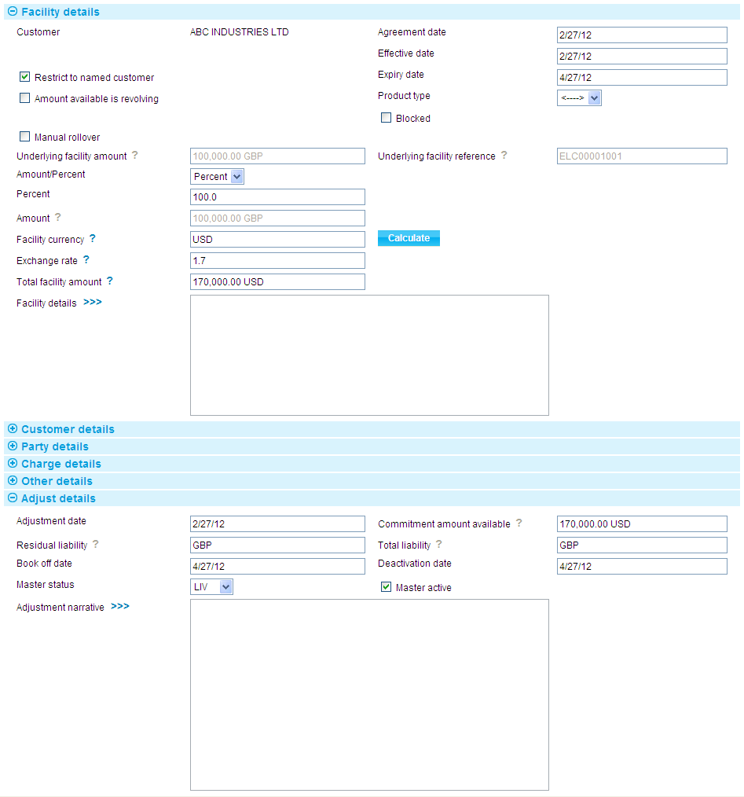

The system displays information already entered for the export credit agency facility, which you can overtype.

If the export credit agency facility is to be blocked check the Blocked flag.

An Adjust Details pane provides additional fields. The following table lists these and explains what to enter into them:

|  |  |
| --- | --- |
| Field | What it Shows |
| Adjustment Date | The date the adjustment was made. This defaults to today's date. |
| Commitment Amount Available | The commitment amount is calculated as the original commitment amount, minus any drawdown made against the export credit agency facility. |
| Residual Liability | The system displays the current residual liability amount for the export credit agency facility. If the Adjust event has postings set up for it, then the amount you enter here should reflect the residual liability amount before those postings take effect. The postings generated for the event will then reduce or increase the residual liability amount.  If no postings are set up for the Adjust event, then enter here the residual liability amount after the Adjust event has completed. |
| Book Off Date | The system displays the export credit agency facility's book-off date, which you can amend. |
| Deactivation Date | The system displays the date on which the export credit agency facility will become inactive (after its expiry date and any days grace period has elapsed). You can amend this date. |
| Master Status | The status of the export credit agency facility's master record after the Adjust event is released. |
| Master Active | Leave this checked if the master record is to continue to be active; uncheck it to deactivate the master record. |
| Adjustment Narrative | Identify the changes made and the reasons they were made. |

# Cancelling an Export Credit Agency Facility

This chapter explains how to use the system to cancel an export credit agency facility.

## Cancelling an Export Credit Agency Facility

An export credit agency facility can be cancelled at any time after the release of the Create event and before book-off.

When you initiate a Cancel event against an export credit agency facility, the system produces a warning message if the facility is currently linked to any financing transactions. If you proceed to cancel the facility, those financing transactions are unaffected. Once the facility is cancelled you will not be able to link any further financing transactions to it.

## Entering Details of the Cancellation

To cancel an export credit agency facility, with the appropriate master record open, in the Master Summary window select 'Cancel EC Agency Facility' from the Create New Event drop-down list and press Create. The system opens the event at either at a Log step or Input step. Depending on how your system is configured, panes and fields available in log steps can be tailored for each data capture step. See the *SDK - Screen Tailoring User Guide* – Trade Innovation for details.

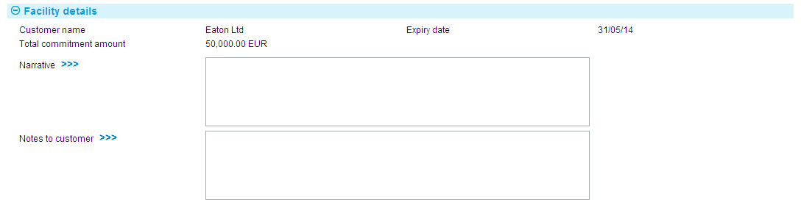

The Facility Details pane shows details of the customer, the expiry date, and the total commitment amount for the facility.

Use the Narrative field to enter the reason for the cancellation and the Notes to Customer field to record any information to be included on documents to be sent to the customer regarding the cancellation.

# Drawdowns, Payments and Cost of Funds Payments

This chapter explains how the system handles drawdowns and payments against an export credit agency facility, and how it handles the payment of cost-of-funds interest to export credit agencies.

## After You have Linked a Financing Transaction to an Export Credit Agency Facility

When you complete the Create event for a financing transaction that has been linked to a pre-existing export credit agency facility the system automatically creates a Drawdown/Revolve Facility event against that export credit agency facility. This event is created as a subsidiary event of the financing transaction's Create event and it reduces the available amount of the facility.

The Drawdown/Revolve Facility event is listed in the export credit agency facility's Master Summary window, in the Event History pane.

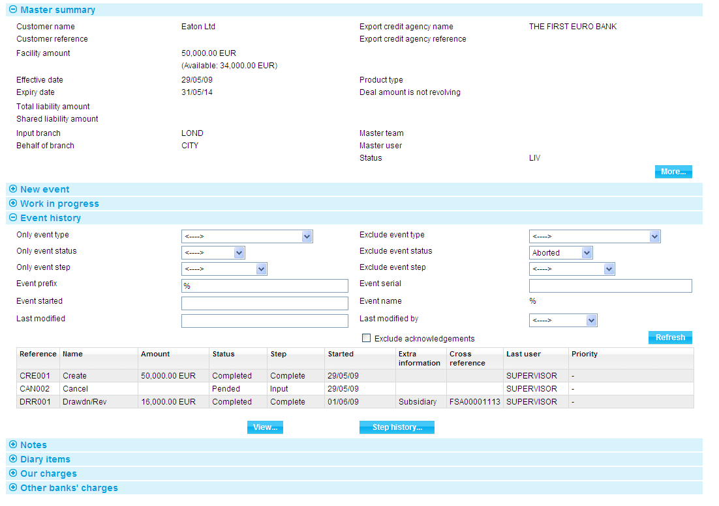

Selecting the event and pressing View shows details of the drawdown.

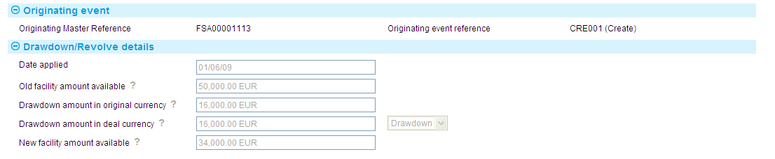

The Old Facility Amount Available represents the amount available under the facility before this drawdown was applied to it. The New Facility Amount Available is the amount after this drawdown was applied.

If you create a new export credit agency facility from within a financing transaction the system creates two subsidiary events for the financing transaction Create event - one to create the new export credit agency facility (and its master record), and one to create a drawdown against it. These subsidiary events are validated at the same time as the financing transaction.

The Related Masters link in the Master Summary window for a financing transaction shows details of the export credit agency facility to which it is linked.

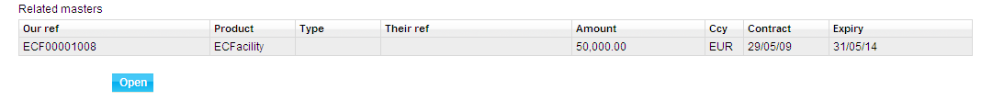

The Related Masters link in the Master Summary window for an export credit agency facility shows details of the financing transactions to which it is linked.

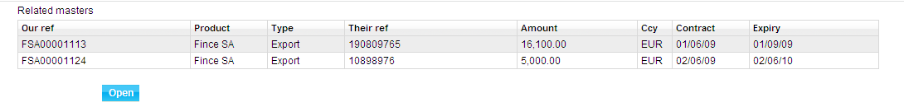

Once you have linked a financing transaction to an export credit agency facility, the system will create a Drawdown/Revolve Facility event against that facility reducing its available amount whenever you increase the amount of the financing transaction. The system will validate any such amendments to ensure that they do not cause the amount or tenor of the export credit agency facility to be exceeded.

Similarly, when you attempt to amend an export credit agency facility, the system will take into account the amount and tenor of the financing transactions linked to it, and will not allow either the commitment amount to be reduced to less than the total of all drawdowns recorded against it; or the expiry date to be earlier than that of any linked financing transaction.

Payments against financing transactions also create Drawdown/Revolve Facility events against their related export credit agency facility. If the facility is revolving, the Drawdown/Revolve Facility event increases the facility's available amount by the amount repaid.

## Cost of Funds Payments

For financing transactions linked to export credit agency facilities the system allows your bank to define two separate forms of interest:

* Interest for your bank
* Interest levied to meet the cost of funds for the export credit agency

Both types of interest are set up using interest types.

For cost-of-fund interest your bank can define whether the interest is to be calculated and paid as each repayment event is processed; or whether it is to be handled instead by overnight processing. If the latter, at a regular frequency (defined by your bank) the system’s overnight processing will calculate and pay the interest for all financing transactions so flagged, making one payment per product type per export credit agency facility. These settings are defined at product-type level, but can be overridden at individual financing transaction level and at repayment event level.

Interest types provide the schedules and default details used to calculate the interest, and these can also be overridden during transaction processing.

For information on setting up interest types see the System Tailoring User Guide – Trade Innovation. For information on processing cost-of-fund details during transaction processing see the Financing User Guide – Trade Innovation.

### Past Due Processing

Interest schedules for calculating cost-of-funds interest calculations apply from the creation of a financing transaction to its maturity date. Consequently, cost-of-funds interest ceases to accrue when a transaction becomes 'past due'.

The system allows you to set up separate schedules for use in calculating interest once a financing transaction has reached its due date without being paid in full. Such schedules can be defined to increase their interest rate as time passes.